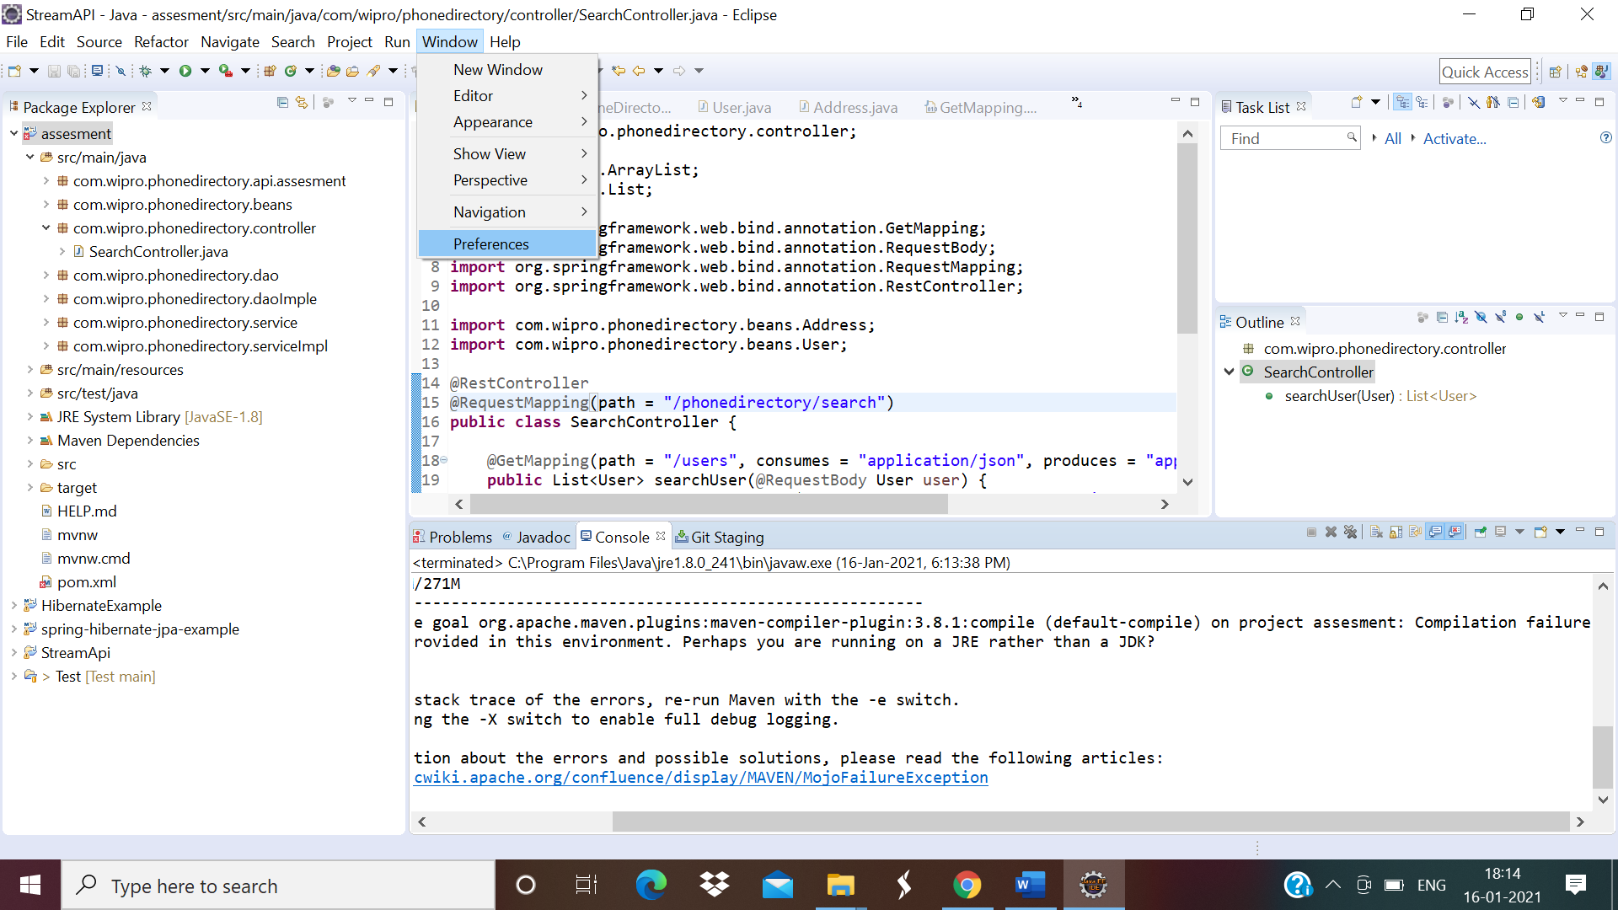



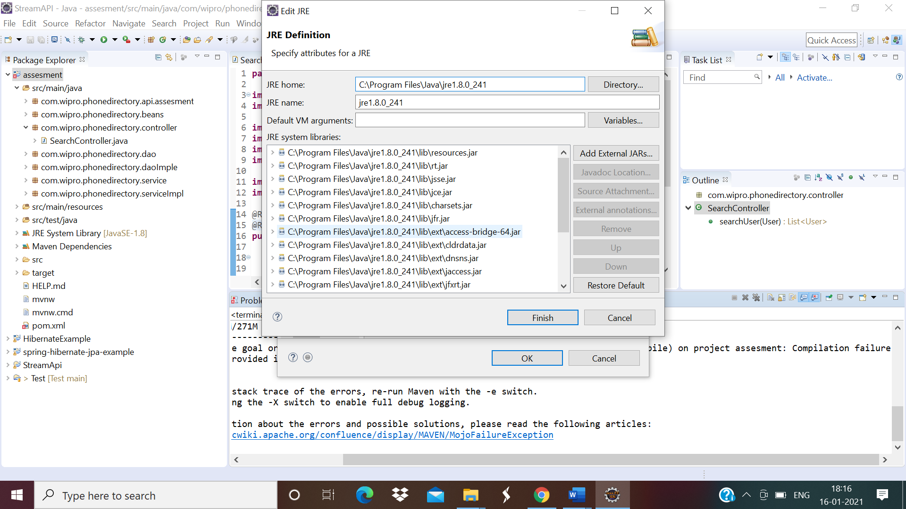

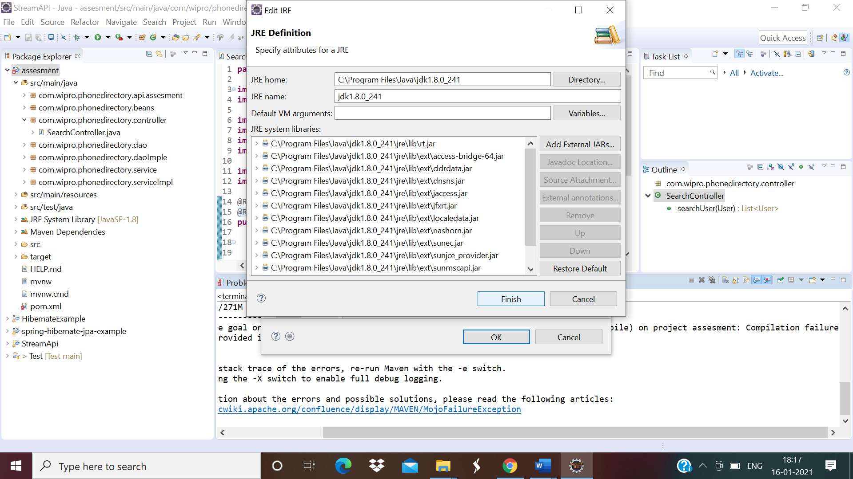

Test case 1

<http://localhost:8085/phonedirectory/search/users>

Method:GET

Request Body:

{

    "firstName":"",

    "middleName":"",

    "lastName":""

}

Response:

{

    "responseCode": 400,

    "responseMessage": "User name is invalid",

    "response": ""

}

Test case 2:

<http://localhost:8085/phonedirectory/search/users>

Method:GET

Request Body:

{

    "firstName":"chhote",

    "middleName":"",

    "lastName":""

}

Response

{

    "responseCode": 200,

    "responseMessage": "success",

    "response": [

        {

            "firstName": "Chhotelal",

            "middleName": "Prasad",

            "lastName": "Gupta",

            "address": {

                "address1": "#3278/1",

                "address2": "Sector-47D",

                "state": "Chandigarh",

                "district": "Chandigarh",

                "zip": 160047,

                "residencePhoneNo": "172-259799",

                "officialPhoneNo": "172-259765"

            },

            "mobileNo": "9891074820"

        }

    ]

}

Test case 3

Exception Scenario

<http://localhost:8085/phonedirectory/search/users>

Method:GET

Request Body:

{

    "firstName":"",

    "middleName":"",

    "lastName":""

}

Response

{

    "responseCode": 400,

    "responseMessage": "User name is invalid",

    "response": ""

}

Test case 4

<http://localhost:8085/phonedirectory/search/user?name=gupta>

Method :GET

Response

{

    "responseCode": 200,

    "responseMessage": "success",

    "response": [

        {

            "firstName": "Chhotelal",

            "middleName": "Prasad",

            "lastName": "Gupta",

            "address": {

                "address1": "#3278/1",

                "address2": "Sector-47D",

                "state": "Chandigarh",

                "district": "Chandigarh",

                "zip": 160047,

                "residencePhoneNo": "172-259799",

                "officialPhoneNo": "172-259765"

            },

            "mobileNo": "9891074820"

        },

        {

            "firstName": "Ajay",

            "middleName": "Kumar",

            "lastName": "Gupta",

            "address": {

                "address1": "#3271/1",

                "address2": "Sector-47D",

                "state": "Chandigarh",

                "district": "Chandigarh",

                "zip": 160047,

                "residencePhoneNo": "172-259799",

                "officialPhoneNo": "172-259765"

            },

            "mobileNo": "9891074820"

        },

        {

            "firstName": "Kumar",

            "middleName": "Sanu",

            "lastName": "Gupta",

            "address": {

                "address1": "#3273/1",

                "address2": "Sector-47D",

                "state": "Chandigarh",

                "district": "Chandigarh",

                "zip": 160047,

                "residencePhoneNo": "172-259799",

                "officialPhoneNo": "172-259765"

            },

            "mobileNo": "9891074820"

        },

        {

            "firstName": "Vishal",

            "middleName": "Kumar",

            "lastName": "Gupta",

            "address": {

                "address1": "#3280/1",

                "address2": "Sector-47D",

                "state": "Chandigarh",

                "district": "Chandigarh",

                "zip": 160047,

                "residencePhoneNo": "172-259799",

                "officialPhoneNo": "172-259765"

            },

            "mobileNo": "9891074820"

        },

        {

            "firstName": "Somanath",

            "middleName": "Laheri",

            "lastName": "Gupta",

            "address": {

                "address1": "#3281/1",

                "address2": "Sector-47D",

                "state": "Chandigarh",

                "district": "Chandigarh",

                "zip": 160047,

                "residencePhoneNo": "172-259799",

                "officialPhoneNo": "172-259765"

            },

            "mobileNo": "9891074820"

        },

        {

            "firstName": "Tejashi",

            "middleName": "Kumar",

            "lastName": "Gupta",

            "address": {

                "address1": "#3282/1",

                "address2": "Sector-47D",

                "state": "Chandigarh",

                "district": "Chandigarh",

                "zip": 160047,

                "residencePhoneNo": "172-259799",

                "officialPhoneNo": "172-259765"

            },

            "mobileNo": "9891074820"

        },

        {

            "firstName": "Ranjana",

            "middleName": "Kumari",

            "lastName": "Gupta",

            "address": {

                "address1": "#3284/1",

                "address2": "Sector-47D",

                "state": "Chandigarh",

                "district": "Chandigarh",

                "zip": 160047,

                "residencePhoneNo": "172-259799",

                "officialPhoneNo": "172-259765"

            },

            "mobileNo": "9891074820"

        }

    ]

}